HRP-817 | 09/25/2026

FORM: Site Closure
Use as a final report to close an external study site and discontinue VCU IRB oversight. This form should be completed by the site PI or the VCU PI, if the site PI is no longer available.
Any changes to the VCU study unrelated to this site closure must be submitted under a separate request for a modification.
basic information
Basic Study Information | Study Details
IRB Number (if known): | Click or tap here to enter text.
Study Title: | Click or tap here to enter text.
Short Title: | Click or tap here to enter text.
Site Investigator: | Click or tap here to enter text.
Site Primary Contact: | Click or tap here to enter text.

Site Enrollment Status
Enrollment Status | Site Enrollment Details
Number of subjects enrolled at this site in total: | Click or tap here to enter text.
Number of subjects enrolled at this site since last approval: | Click or tap here to enter text.

Current SITE Status
Research milestones (select all that apply):
☐ Study site is permanently closed to enrollment OR was never open for enrollment.
☐ All subjects have completed all study-related interventions OR not applicable (e.g. study did not include interventions, no subjects were enrolled).
☐ Collection of private identifiable information is complete OR not applicable (no subjects were enrolled).
☐ Analysis of private identifiable information is complete OR not applicable (no subjects were enrolled).

Check all that are true or not applicable.
☐ NO subjects have experienced unexpected harm.
☐ Anticipated Adverse Events have NOT taken place with greater frequency or severity than expected.
☐ NO subjects have withdrawn from the protocol.
☐ There have been NO unanticipated problems involving risks to subjects or others.
☐ There have been NO complaints about the protocol.
☐ There have been NO publications in the literature relevant to risks or potential benefits.
☐ There have been NO interim findings.
☐ There have been NO multi-center trial reports.
☐ There have been NO data safety monitoring reports.
☐ There have been NO modifications to the protocol that have not been submitted to and approved by the IRB.
☐ There have been NO regulatory actions that could affect safety and risk assessments.
☐ There has been NO other relevant information regarding this protocol, such as information about risks.
☐ In the opinion of the principal investigator, the risks or potential benefits are unchanged.
☐ All problems that require prompt reporting to the IRB have been submitted.

Site information
Provide one copy of the following documents:
- Explanation of any items above which you did not check as being true.

Investigator Acknowledgement
I will conduct this protocol in accordance with requirements this IRB’s requirements and any relevant local requirements. I acknowledge that the reliance agreement between my site and VCU will be terminated per the agreed-upon communication plan.
Investigator Signature
Date of Signature: Click or tap here to enter text.
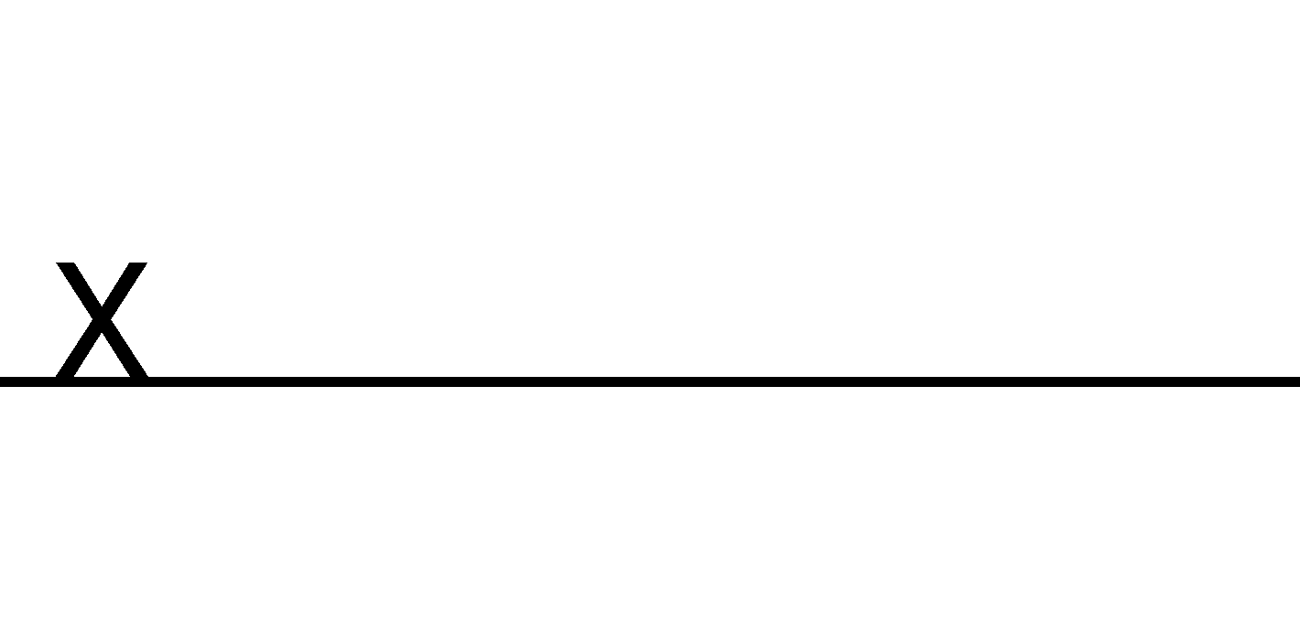

This document satisfies AAHRPP elements I.6.B, I-9, II.2.E-II.2.E.2, II.2.F-II.2.F.3, II.3.A, II.3.C-II.3.C.1, III.1.B
This refers to the status of the protocol under the supervision of the investigator, not the status of the protocol at all centers.

